In-Depth Research Report on:-File Path Traversal, File Inclusion Vulnerabilities (LFI/RFI), and File Upload Vulnerabilities

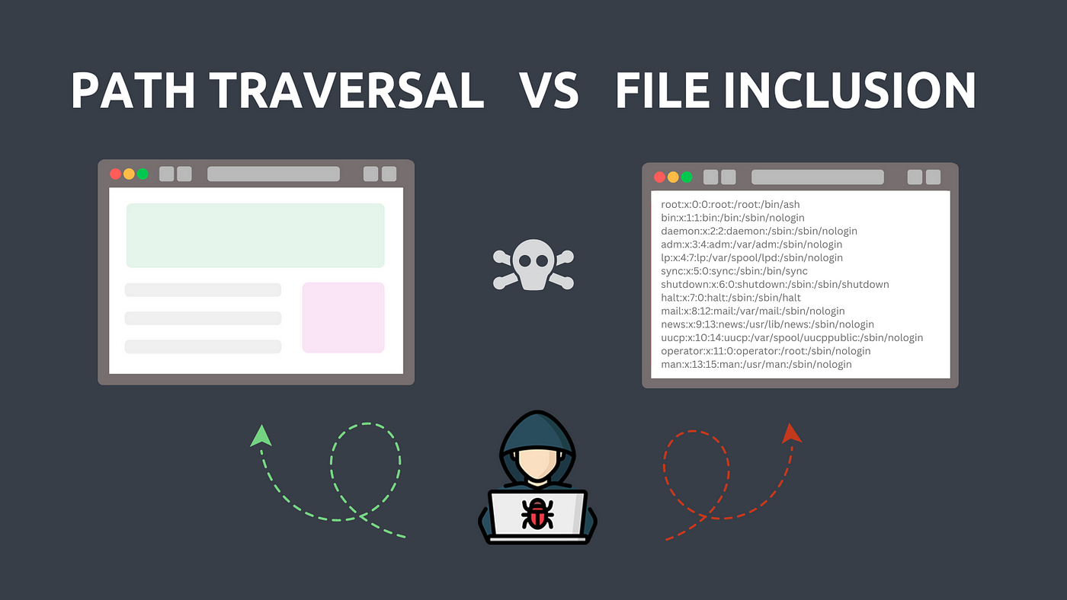

1. Introduction

Overview of File Vulnerabilities
File vulnerabilities refer to security flaws related to file handling within web applications. These vulnerabilities can be exploited to gain unauthorized access to sensitive information, execute arbitrary code, or disrupt service.

Importance of Addressing File Vulnerabilities
Addressing these vulnerabilities is critical to maintaining data integrity, user trust, and compliance with regulations. Organizations can avoid substantial financial losses and reputational damage by implementing robust security measures.
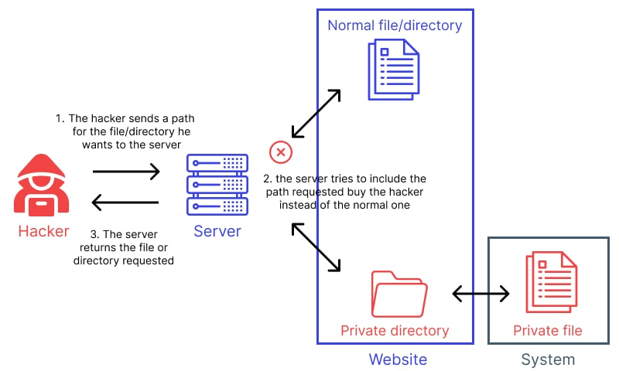

2. File Path Traversal

2.1 Definition
File path traversal, also known as directory traversal, is a security vulnerability that allows an attacker to access files and directories outside the intended directory structure of an application. This is typically done by manipulating input fields to include special characters such as ../.

2.2 Mechanism
An attacker exploits this vulnerability by crafting requests that include path traversal sequences. For example, a URL such as http://example.com/getfile.php?file=../../etc/passwd could allow access to sensitive system files.

2.3 Impact
- Financial: Organizations may incur costs related to data breaches, remediation efforts, and legal fees.
- Reputational: Breaches can lead to loss of customer trust and damage to brand reputation.
- Security: Sensitive data exposure may lead to further attacks, including identity theft and system compromise
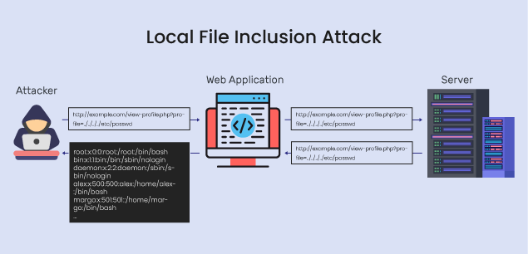

3. File Inclusion Vulnerability

3.1 Definition
File inclusion vulnerabilities occur when an application includes files without proper validation. Attackers can exploit these vulnerabilities to execute arbitrary code or include malicious files.

3.2 Types
- Local File Inclusion (LFI): An attacker can include files from the local server, which may allow them to read sensitive files (e.g., /etc/passwd) or execute local scripts.
- Remote File Inclusion (RFI): An attacker can include files from a remote server. This often allows the attacker to execute malicious code stored on an external server.

3.3 Impact
- Security: Exploitation can lead to unauthorized access and full server compromise.
- Data Integrity: Attackers may modify or delete critical files, leading to data corruption.
- Operational Risks: Service outages may occur due to unauthorized actions taken by the attacker.
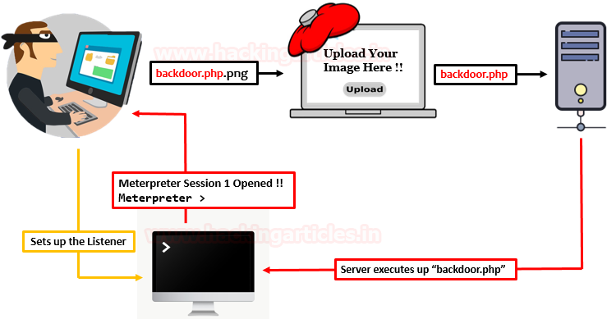

4. File Upload Vulnerability

4.1 Definition
File upload vulnerabilities occur when an application allows users to upload files without sufficient validation or restrictions. This can lead to the execution of malicious files on the server.

4.2 Impact
- Malware Distribution: Attackers can upload malicious files that can infect other users or systems.
- Unauthorized Access: Malicious files may exploit other vulnerabilities to gain unauthorized access to sensitive data.
- Service Disruption: Compromised systems may lead to service outages or performance degradation.

5. Mitigation Strategies

General Practices for All Vulnerabilities
- Input Validation: Always validate and sanitize user inputs to prevent malicious data entry.
- Least Privilege Principle: Ensure that applications run with the minimum privileges necessary to function.
- Web Application Firewalls (WAF): Use WAFs to filter out malicious requests and protect against known vulnerabilities.

Specific Strategies for Each Type
- File Path Traversal: Implement strict whitelisting of file paths and utilize functions that restrict access to predetermined directories.
- File Inclusion Vulnerability: Ensure that all file includes are validated against a list of allowed files. Avoid using user input directly in file paths.
- File Upload Vulnerability: Enforce file type restrictions, limit upload sizes, and store uploaded files outside of the web root. Implement antivirus scanning for uploaded files.

6. Conclusion

Summary of Key Points
File path traversal, file inclusion vulnerabilities (LFI/RFI), and file upload vulnerabilities pose significant risks to web applications. Understanding these vulnerabilities and their impacts is essential for organizations to protect sensitive data and maintain operational integrity.

Future Directions in Vulnerability Management
As technology evolves, so do the techniques used by attackers. Continuous education, rigorous testing, and adaptive security measures will be crucial in defending against emerging threats.

7. References
- OWASP. (2023). OWASP Top Ten - 2023. OWASP Website
- Reddy, S. (2020). Web Application Vulnerabilities: A Comprehensive Guide. Journal of Cybersecurity, 14(2), 123-145.
- McGraw, G. (2006). Software Security: Building Security In. Addison-Wesley.
- SecurityFocus. (2022). Understanding File Inclusion Vulnerabilities. SecurityFocus Article
- SANS Institute. (2021). File Upload Vulnerabilities: Risks and Mitigation. SANS Whitepaper

